SEC Form 4

FORM 4

Check this box if no longer subject to Section 16. Form 4 or Form 5 obligations may continue. See Instruction 1(b).

UNITED STATES SECURITIES AND EXCHANGE COMMISSION
Washington, D.C. 20549
 |  | OMB APPROVAL
STATEMENT OF CHANGES IN BENEFICIAL OWNERSHIP
 |  | OMB Number: | 3235-0287
 |  | Estimated average burden
Filed pursuant to Section 16(a) of the Securities Exchange Act of 1934 |  | hours per response: | 0.5
or Section 30(h) of the Investment Company Act of 1940
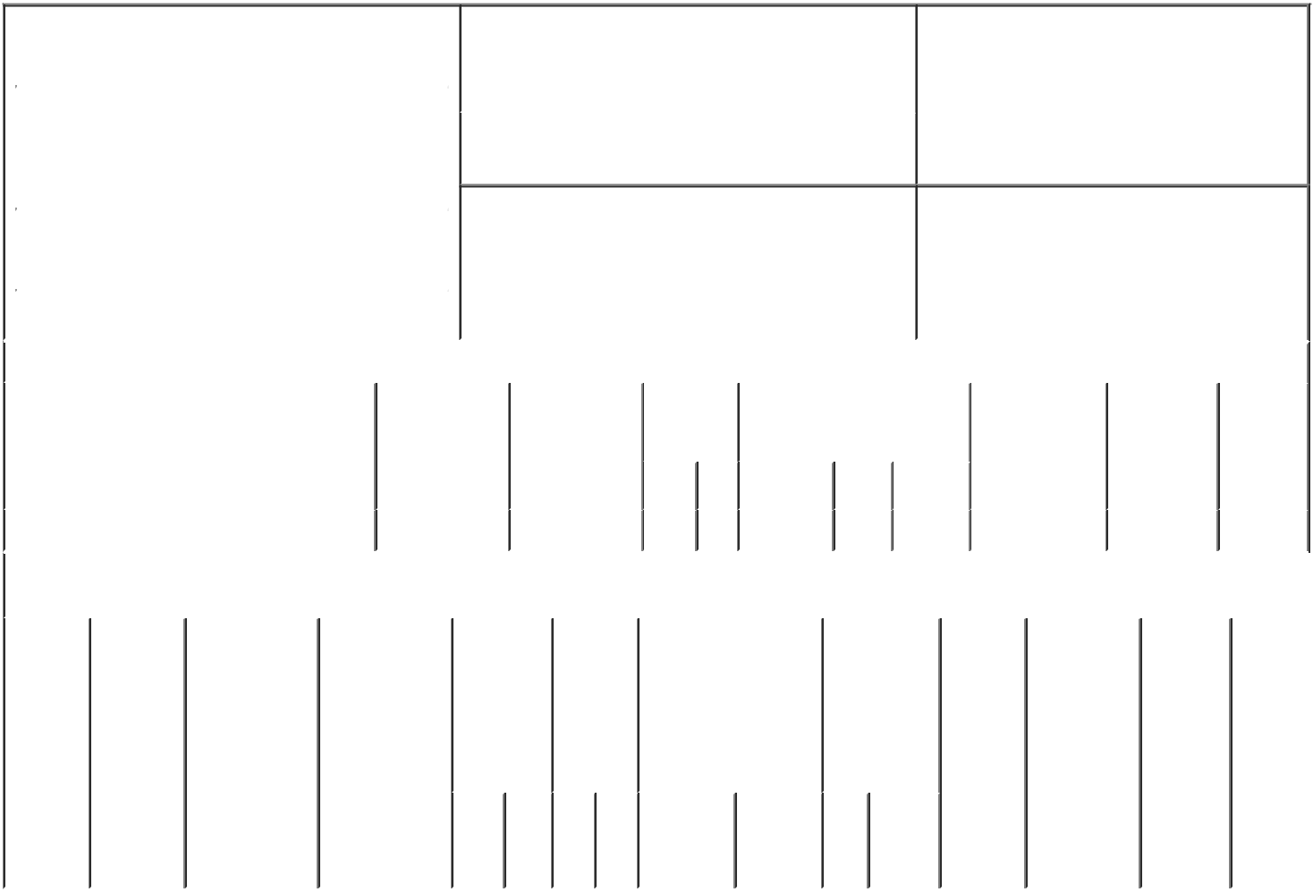

1. Name and Address of Reporting Person* |  |  |  |  |  |  | 2. Issuer Name and Ticker or Trading Symbol
 | Moen Brent |  |  |  |  |  | TACTILE SYSTEMS TECHNOLOGY
 |  |  |  |  |  |  | INC [ TCMD ]
 | (Last) |  | (First) | (Middle)
 |  |  |  |  |  |  | 3. Date of Earliest Transaction (Month/Day/Year)
 | 3701 WAYZATA BLVD.
 |  |  |  |  | 03/05/2020

SUITE 300

- Relationship of Reporting Person(s) to Issuer (Check all applicable)

 | Director | 10% Owner
X | Officer (give title | Other (specify
 | below) | below)

Chief Financial Officer

 |  |  |  |  |  |  | 4. If Amendment, Date of Original Filed (Month/Day/Year) |  |  |  |  |  |  | 6. Individual or Joint/Group Filing (Check Applicable
 | (Street) |  |  |  |  |  |  |  |  |  |  |  |  | Line)
 |  |  |  |  |  |  |  |  |  |  |  |  |  |  |  | X Form filed by One Reporting Person
 |  | MINNEAPOLIS MN |  |  | 55416
 |  |  |  |  |  |  |  |  |  |  |  |  |  |  |  |  | Form filed by More than One Reporting
 |  |  |  |  |  |  |  |  |  |  |  |  |  |  |  |  | Person
 |  | (City) | (State) |  | (Zip)
 |  |  |  | Table I - Non-Derivative Securities Acquired, Disposed of, or Beneficially Owned
 | 1. Title of Security (Instr. 3) |  |  |  | 2. Transaction |  |  | 2A. Deemed |  | 3. | 4. Securities Acquired (A) or |  |  |  |  |  | 5. Amount of |  | 6. Ownership | 7. Nature
 |  |  |  |  | Date |  |  | Execution Date, |  | Transaction | Disposed Of (D) (Instr. 3, 4 and |  |  |  |  |  | Securities |  | Form: Direct | of Indirect
 |  |  |  |  | (Month/Day/Year) |  |  | if any |  | Code (Instr. | 5) |  |  |  |  |  | Beneficially |  | (D) or Indirect | Beneficial
 |  |  |  |  |  |  |  | (Month/Day/Year) |  | 8) |  |  |  |  |  |  | Owned Following |  | (I) (Instr. 4) | Ownership
 |  |  |  |  |  |  |  |  |  |  |  |  |  |  |  |  | Reported |  |  | (Instr. 4)
 |  |  |  |  |  |  |  |  |  | Code V | Amount | (A) or |  | Price |  |  | Transaction(s)
 |  |  |  |  |  |  |  |  |  |  |  | (D) |  |  |  |  | (Instr. 3 and 4)
 | Common Stock |  |  |  | 03/05/2020 |  |  |  |  | S | 175⁽¹⁾ | D |  | $48.64 |  |  | 23,897 |  | D
 |  |  |  |  | Table II - Derivative Securities Acquired, Disposed of, or Beneficially Owned
 |  |  |  |  | (e.g., puts, calls, warrants, options, convertible securities)
 | 1. Title of |  | 2. | 3. Transaction | 3A. Deemed | 4. |  |  | 5. Number | 6. Date Exercisable and |  | 7. Title and |  |  |  | 8. Price of |  | 9. Number of 10. |  | 11. Nature
 | Derivative |  | Conversion | Date | Execution Date, |  | Transaction |  | of | Expiration Date |  | Amount of |  |  |  | Derivative |  | derivative | Ownership | of Indirect
 | Security |  | or Exercise | (Month/Day/Year) if any |  |  | Code (Instr. |  | Derivative | (Month/Day/Year) |  | Securities |  |  |  | Security |  | Securities | Form: | Beneficial
 | (Instr. 3) |  | Price of |  | (Month/Day/Year) | 8) |  |  | Securities |  |  | Underlying |  |  |  | (Instr. 5) |  | Beneficially | Direct (D) | Ownership
 |  |  | Derivative |  |  |  |  |  | Acquired |  |  | Derivative |  |  |  |  |  | Owned | or Indirect | (Instr. 4)
 |  |  | Security |  |  |  |  |  | (A) or |  |  | Security (Instr. |  |  |  |  |  | Following | (I) (Instr. 4)
 |  |  |  |  |  |  |  |  | Disposed |  |  | 3 and 4) |  |  |  |  |  | Reported
 |  |  |  |  |  |  |  |  | of (D) |  |  |  |  |  |  |  |  | Transaction(s)
 |  |  |  |  |  |  |  |  | (Instr. 3, 4 |  |  |  |  |  |  |  |  | (Instr. 4)
 |  |  |  |  |  |  |  |  | and 5)
 |  |  |  |  |  |  |  |  |  |  |  |  | Amount
 |  |  |  |  |  |  |  |  |  |  |  |  | or
 |  |  |  |  |  |  |  |  |  |  |  |  | Number
 |  |  |  |  |  |  |  |  |  | Date | Expiration |  | of
 |  |  |  |  |  |  | Code | V | (A) (D) | Exercisable | Date | Title | Shares

Explanation of Responses:

1. The shares were sold to cover taxes associated with the settlement of stock units. These sales were effected pursuant to a Rule 10b5-1 trading plan adopted by the reporting person on May 31, 2019.

/s/ Jonathan R. Zimmerman, |  |  | 03/09/2020
Attorney-in-Fact
** Signature of Reporting PersonDate

Reminder: Report on a separate line for each class of securities beneficially owned directly or indirectly.

* If the form is filed by more than one reporting person, see Instruction 4 (b)(v).

- Intentional misstatements or omissions of facts constitute Federal Criminal Violations See 18 U.S.C. 1001 and 15 U.S.C. 78ff(a). Note: File three copies of this Form, one of which must be manually signed. If space is insufficient, see Instruction 6 for procedure.
Persons who respond to the collection of information contained in this form are not required to respond unless the form displays a currently valid OMB Number.

