SEC Form 4

FORM 4

Check this box if no longer subject to Section 16. Form 4 or Form 5 obligations may continue. See Instruction 1(b).

UNITED STATES SECURITIES AND EXCHANGE COMMISSION
Washington, D.C. 20549
 |  | OMB APPROVAL
STATEMENT OF CHANGES IN BENEFICIAL OWNERSHIP
 |  | OMB Number: | 3235-0287
 |  | Estimated average burden
Filed pursuant to Section 16(a) of the Securities Exchange Act of 1934 |  | hours per response: | 0.5
or Section 30(h) of the Investment Company Act of 1940
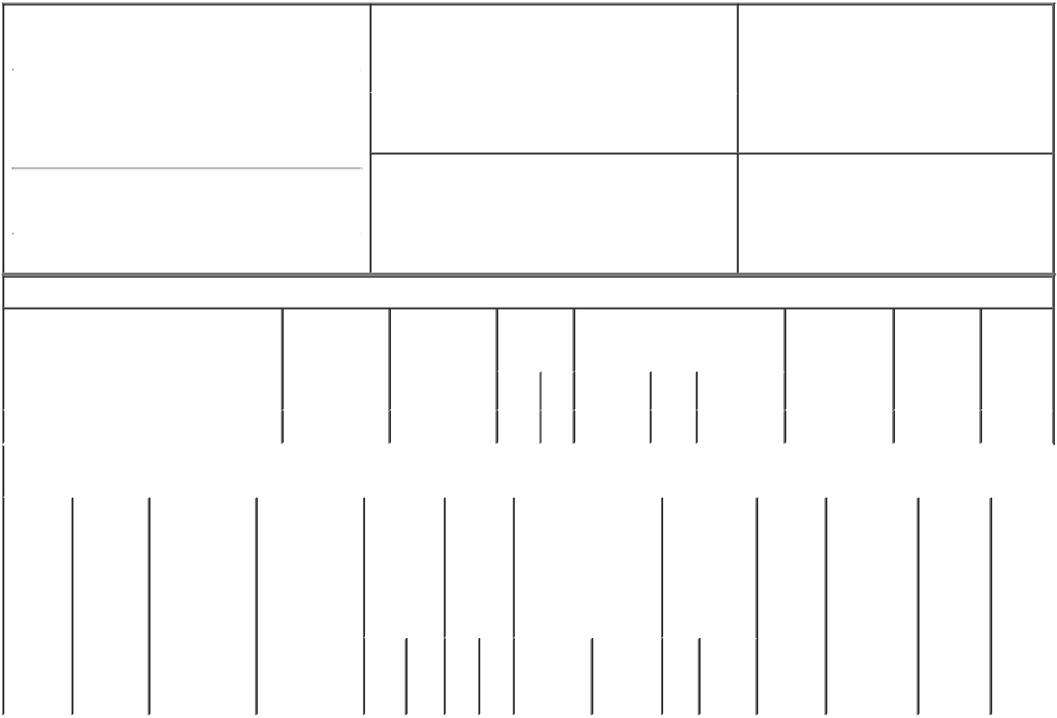

1. Name and Address of Reporting Person* |  |  |  |  |  |  | 2. Issuer Name and Ticker or Trading Symbol
 | REUVERS DANIEL L. |  |  |  |  |  | TACTILE SYSTEMS TECHNOLOGY
 |  |  |  |  |  |  | INC [ TCMD ]
 | (Last) | (First) |  | (Middle)

3701 WAYZATA BLVD. | 3. Date of Earliest Transaction (Month/Day/Year)
 | 08/06/2021
SUITE 300

- Relationship of Reporting Person(s) to Issuer (Check all applicable)

X | Director | 10% Owner
X | Officer (give title | Other (specify
 | below) | below)

President and CEO

(Street)
 | MINNEAPOLIS MN |  | 55416
 | (City) | (State) | (Zip)

4. If Amendment, Date of Original Filed (Month/Day/Year) 6. Individual or Joint/Group Filing (Check Applicable
Line)
X Form filed by One Reporting Person

Form filed by More than One Reporting
Person

Table I - Non-Derivative Securities Acquired, Disposed of, or Beneficially Owned

 | 1. Title of Security (Instr. 3) |  |  | 2. Transaction |  | 2A. Deemed |  |  | 3. |  | 4. Securities Acquired (A) or |  |  |  |  | 5. Amount of |  | 6. Ownership | 7. Nature
 |  |  |  | Date |  | Execution Date, |  |  | Transaction |  | Disposed Of (D) (Instr. 3, 4 and 5) |  |  |  |  | Securities |  | Form: Direct | of Indirect
 |  |  |  | (Month/Day/Year) if any |  |  |  |  | Code (Instr. |  |  |  |  |  |  | Beneficially |  | (D) or | Beneficial
 |  |  |  |  |  | (Month/Day/Year) |  |  | 8) |  |  |  |  |  |  | Owned Following |  | Indirect (I) | Ownership
 |  |  |  |  |  |  |  |  |  |  |  |  |  |  |  | Reported |  | (Instr. 4) | (Instr. 4)
 |  |  |  |  |  |  |  |  | Code V |  | Amount | (A) or | Price |  |  | Transaction(s)
 |  |  |  |  |  |  |  |  |  |  |  | (D) |  |  |  | (Instr. 3 and 4)
 | Common Stock |  |  | 08/06/2021 |  |  |  |  |  | S | 1,063⁽¹⁾ | D | $43.1121⁽²⁾ |  |  | 22,667 |  | D
 |  |  | Table II - Derivative Securities Acquired, Disposed of, or Beneficially Owned
 |  |  |  | (e.g., puts, calls, warrants, options, convertible securities)
 | 1. Title of | 2. | 3. Transaction | 3A. Deemed |  | 4. | 5. Number |  |  | 6. Date Exercisable and |  | 7. Title and |  |  | 8. Price of |  | 9. Number of 10. |  | 11. Nature
 | Derivative | Conversion | Date | Execution Date, |  | Transaction | of |  |  | Expiration Date |  | Amount of |  |  | Derivative |  | derivative | Ownership | of Indirect
 | Security | or Exercise | (Month/Day/Year) | if any |  | Code (Instr. | Derivative |  |  | (Month/Day/Year) |  | Securities |  |  | Security |  | Securities | Form: | Beneficial
 | (Instr. 3) | Price of |  | (Month/Day/Year) |  | 8) | Securities |  |  |  |  | Underlying |  |  | (Instr. 5) |  | Beneficially | Direct (D) | Ownership
 |  | Derivative |  |  |  |  | Acquired |  |  |  |  | Derivative |  |  |  |  | Owned | or Indirect | (Instr. 4)
 |  | Security |  |  |  |  | (A) or |  |  |  |  | Security (Instr. |  |  |  |  | Following | (I) (Instr. 4)
 |  |  |  |  |  |  | Disposed |  |  |  |  | 3 and 4) |  |  |  |  | Reported
 |  |  |  |  |  |  | of (D) |  |  |  |  |  |  |  |  |  | Transaction(s)
 |  |  |  |  |  |  | (Instr. 3, 4 |  |  |  |  |  |  |  |  |  | (Instr. 4)
 |  |  |  |  |  |  | and 5)
 |  |  |  |  |  |  |  |  |  |  |  |  | Amount
 |  |  |  |  |  |  |  |  |  |  |  |  | or
 |  |  |  |  |  |  |  |  |  |  |  |  | Number
 |  |  |  |  |  |  |  |  |  | Date | Expiration |  | of
 |  |  |  |  |  | Code V | (A) (D) |  |  | Exercisable Date |  | Title | Shares

Explanation of Responses:

- The shares were sold to cover taxes associated with the settlement of restricted stock units.

- Reflects the weighted average price of 1,063 shares of common stock of Tactile Systems Technology, Inc. sold by the reporting person in multiple transactions on August 6, 2021 with sale prices ranging from $43.10 to $43.1622 per share. The reporting person undertakes to provide upon request by the U.S. Securities and Exchange Commission staff, the issuer, or a security holder of the issuer, full information regarding the number of shares sold at each separate price.

/s/ Jonathan Zimmerman, |  |  | 08/09/2021
Attorney-in-Fact
** Signature of Reporting PersonDate

Reminder: Report on a separate line for each class of securities beneficially owned directly or indirectly.

* If the form is filed by more than one reporting person, see Instruction 4 (b)(v).

- Intentional misstatements or omissions of facts constitute Federal Criminal Violations See 18 U.S.C. 1001 and 15 U.S.C. 78ff(a). Note: File three copies of this Form, one of which must be manually signed. If space is insufficient, see Instruction 6 for procedure.
Persons who respond to the collection of information contained in this form are not required to respond unless the form displays a currently valid OMB Number.

