SEC Form 4

FORM 4

Check this box if no longer subject to Section 16. Form 4 or Form 5 obligations may continue. See Instruction 1(b).

UNITED STATES SECURITIES AND EXCHANGE COMMISSION
Washington, D.C. 20549
 |  | OMB APPROVAL
STATEMENT OF CHANGES IN BENEFICIAL OWNERSHIP
 |  | OMB Number: | 3235-0287
 |  | Estimated average burden
Filed pursuant to Section 16(a) of the Securities Exchange Act of 1934 |  | hours per response: | 0.5
or Section 30(h) of the Investment Company Act of 1940
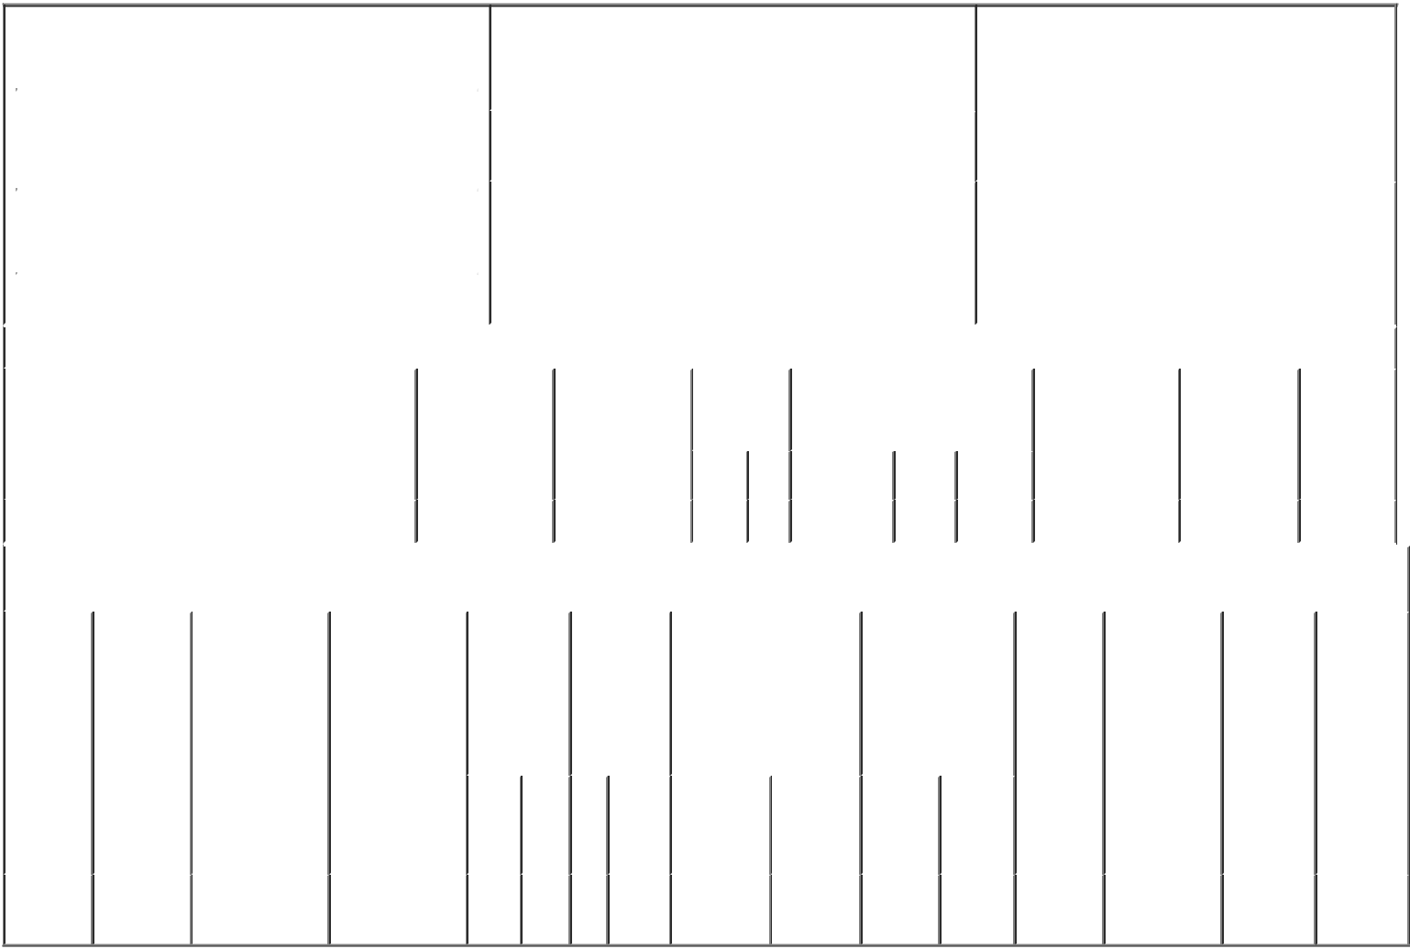

 | 1. Name and Address of Reporting Person* |  |  |  |  |  |  | 2. Issuer Name and Ticker or Trading Symbol |  |  |  |  |  |  |  |  |  |  |  | 5. Relationship of Reporting Person(s) to Issuer
 |  | Mattys Gerald R. |  |  |  |  |  | TACTILE SYSTEMS TECHNOLOGY |  |  |  |  |  |  |  |  |  |  |  | (Check all applicable)
 |  |  |  |  |  |  |  |  |  |  |  |  |  |  |  |  |  |  |  | X |  |  | Director |  |  | 10% Owner
 |  |  |  |  |  |  |  | INC [ TCMD ]
 |  |  |  |  |  |  |  |  |  |  |  |  |  |  |  |  |  |  |  |  |  |  | Officer (give title |  |  | Other (specify
 |  |  |  |  |  |  |  |  |  |  |  |  |  |  |  |  |  |  |  | X
 |  | (Last) | (First) |  | (Middle) |  |  |  |  |  |  |  |  |  |  |  |  |  |  |  |  |  | below) |  |  | below)
 |  |  |  |  |  |  |  | 3. Date of Earliest Transaction (Month/Day/Year)
 |  |  |  |  |  |  |  |  |  |  |  |  |  |  |  |  |  |  |  |  |  |  | Chief Executive Officer
 |  | 1331 TYLER STREET NE, SUITE 200 |  |  |  | 08/02/2016
 |  |  |  |  |  |  |  | 4. If Amendment, Date of Original Filed (Month/Day/Year) |  |  |  |  |  |  |  |  |  |  |  | 6. Individual or Joint/Group Filing (Check Applicable
 | (Street)
 |  |  |  |  |  | 08/04/2016 |  |  |  |  |  |  |  |  |  |  |  |  |  | Line)
 |  | MINNEAPOLIS MN |  |  | 55413 |  |  |  |  |  |  |  |  |  |  |  |  |  |  | X Form filed by One Reporting Person
 |  |  |  |  |  |  |  |  |  |  |  |  |  |  |  |  |  |  |  |  |  |  | Form filed by More than One Reporting
 |  | (City) | (State) |  | (Zip) |  |  |  |  |  |  |  |  |  |  |  |  |  |  |  |  |  | Person
 |  |  |  | Table I - Non-Derivative Securities Acquired, Disposed of, or Beneficially Owned
 | 1. Title of Security (Instr. 3) |  |  |  | 2. Transaction |  |  |  |  |  | 2A. Deemed | 3. |  |  | 4. Securities Acquired (A) or |  |  |  |  |  |  |  | 5. Amount of |  | 6. Ownership |  | 7. Nature
 |  |  |  |  | Date |  |  |  |  |  | Execution Date, |  | Transaction |  | Disposed Of (D) (Instr. 3, 4 and |  |  |  |  |  |  |  | Securities |  | Form: Direct |  | of Indirect
 |  |  |  |  | (Month/Day/Year) |  |  |  |  |  | if any |  | Code (Instr. |  | 5) |  |  |  |  |  |  |  | Beneficially |  | (D) or Indirect |  | Beneficial
 |  |  |  |  |  |  |  |  |  |  | (Month/Day/Year) 8) |  |  |  |  |  |  |  |  |  |  |  | Owned Following |  | (I) (Instr. 4) |  | Ownership
 |  |  |  |  |  |  |  |  |  |  |  |  |  |  |  |  |  |  |  |  |  |  | Reported |  |  |  | (Instr. 4)
 |  |  |  |  |  |  |  |  |  |  |  |  | Code V |  | Amount |  | (A) or |  | Price |  |  |  | Transaction(s)
 |  |  |  |  |  |  |  |  |  |  |  |  |  |  |  |  | (D) |  |  |  |  |  | (Instr. 3 and 4)
 | Common Stock |  |  |  | 08/02/2016 |  |  |  |  |  |  |  | C |  | 39,489 |  |  | A | (1) |  |  |  | 300,973 |  |  | D
 |  |  |  | Table II - Derivative Securities Acquired, Disposed of, or Beneficially Owned
 |  |  |  |  | (e.g., puts, calls, warrants, options, convertible securities)
 | 1. Title of |  | 2. | 3. Transaction | 3A. Deemed | 4. |  |  |  |  | 5. Number | 6. Date Exercisable and |  |  |  | 7. Title and Amount |  |  |  |  |  | 8. Price of |  | 9. Number of |  | 10. | 11. Nature
 | Derivative |  | Conversion | Date | Execution Date, | Transaction |  |  |  |  | of | Expiration Date |  |  |  | of Securities |  |  |  |  |  | Derivative |  | derivative |  | Ownership | of Indirect
 | Security |  | or Exercise | (Month/Day/Year) | if any | Code (Instr. |  |  |  |  | Derivative | (Month/Day/Year) |  |  |  | Underlying |  |  |  |  |  | Security |  | Securities |  | Form: | Beneficial
 | (Instr. 3) |  | Price of |  | (Month/Day/Year) | 8) |  |  |  |  | Securities |  |  |  |  | Derivative Security |  |  |  |  |  | (Instr. 5) |  | Beneficially |  | Direct (D) | Ownership
 |  |  | Derivative |  |  |  |  |  |  |  | Acquired |  |  |  |  | (Instr. 3 and 4) |  |  |  |  |  |  |  | Owned |  | or Indirect | (Instr. 4)
 |  |  | Security |  |  |  |  |  |  |  | (A) or |  |  |  |  |  |  |  |  |  |  |  |  | Following |  | (I) (Instr. 4)
 |  |  |  |  |  |  |  |  |  |  | Disposed |  |  |  |  |  |  |  |  |  |  |  |  | Reported
 |  |  |  |  |  |  |  |  |  |  | of (D) (Instr. |  |  |  |  |  |  |  |  |  |  |  |  | Transaction(s)
 |  |  |  |  |  |  |  |  |  |  | 3, 4 and 5) |  |  |  |  |  |  |  |  |  |  |  |  | (Instr. 4)
 |  |  |  |  |  |  |  |  |  |  |  |  |  |  |  |  |  |  | Amount
 |  |  |  |  |  |  |  |  |  |  |  |  |  |  |  |  |  |  | or
 |  |  |  |  |  |  |  |  |  |  |  |  |  |  |  |  |  |  | Number
 |  |  |  |  |  |  |  |  |  |  |  | Date |  | Expiration |  |  |  |  | of
 |  |  |  |  |  | Code V |  |  |  |  | (A) (D) | Exercisable |  | Date |  | Title |  |  | Shares
 | Series A |  | (1) |  |  |  |  |  |  |  |  | (1) |  |  | (2) | Common |  |  | 27,969 |  |  |  | (1)
 | Preferred |  |  | 08/02/2016 |  |  | C |  |  |  | 27,969 |  |  |  |  |  |  |  |  |  |  |  |  | 0 |  | D
 | Stock |  |  |  |  |  |  |  |  |  |  |  |  |  |  |  | Stock

Explanation of Responses:

- Each share of Series A Preferred Stock was convertible at any time at the option of the holder, and converted automatically into shares of the Issuer's Common Stock on a one for 1.027 basis in connection with the closing of the Issuer's initial public offering. In addition, the holder was entitled to receive additional shares of common stock equal to the original purchase price per share ($4.2301) divided by the price to the public of the shares of common stock issued in the Issuer's initial public offering.

- The securities did not have an expiration date. The securities converted automatically into shares of the Issuer's Common Stock in connection with the closing of the Issuer's initial public offering.

/s/ Jonathan R. Zimmerman, |  |  | 08/19/2016
Attorney-in-Fact
** Signature of Reporting Person |  |  | Date

Reminder: Report on a separate line for each class of securities beneficially owned directly or indirectly.

* If the form is filed by more than one reporting person, see Instruction 4 (b)(v).

- Intentional misstatements or omissions of facts constitute Federal Criminal Violations See 18 U.S.C. 1001 and 15 U.S.C. 78ff(a). Note: File three copies of this Form, one of which must be manually signed. If space is insufficient, see Instruction 6 for procedure.
Persons who respond to the collection of information contained in this form are not required to respond unless the form displays a currently valid OMB Number.

