SEC Form 4

FORM 4

Check this box if no longer subject to Section 16. Form 4 or Form 5 obligations may continue. See Instruction 1(b).

UNITED STATES SECURITIES AND EXCHANGE COMMISSION
Washington, D.C. 20549
 |  | OMB APPROVAL
STATEMENT OF CHANGES IN BENEFICIAL OWNERSHIP
 |  | OMB Number: | 3235-0287
 |  | Estimated average burden
Filed pursuant to Section 16(a) of the Securities Exchange Act of 1934 |  | hours per response: | 0.5
or Section 30(h) of the Investment Company Act of 1940
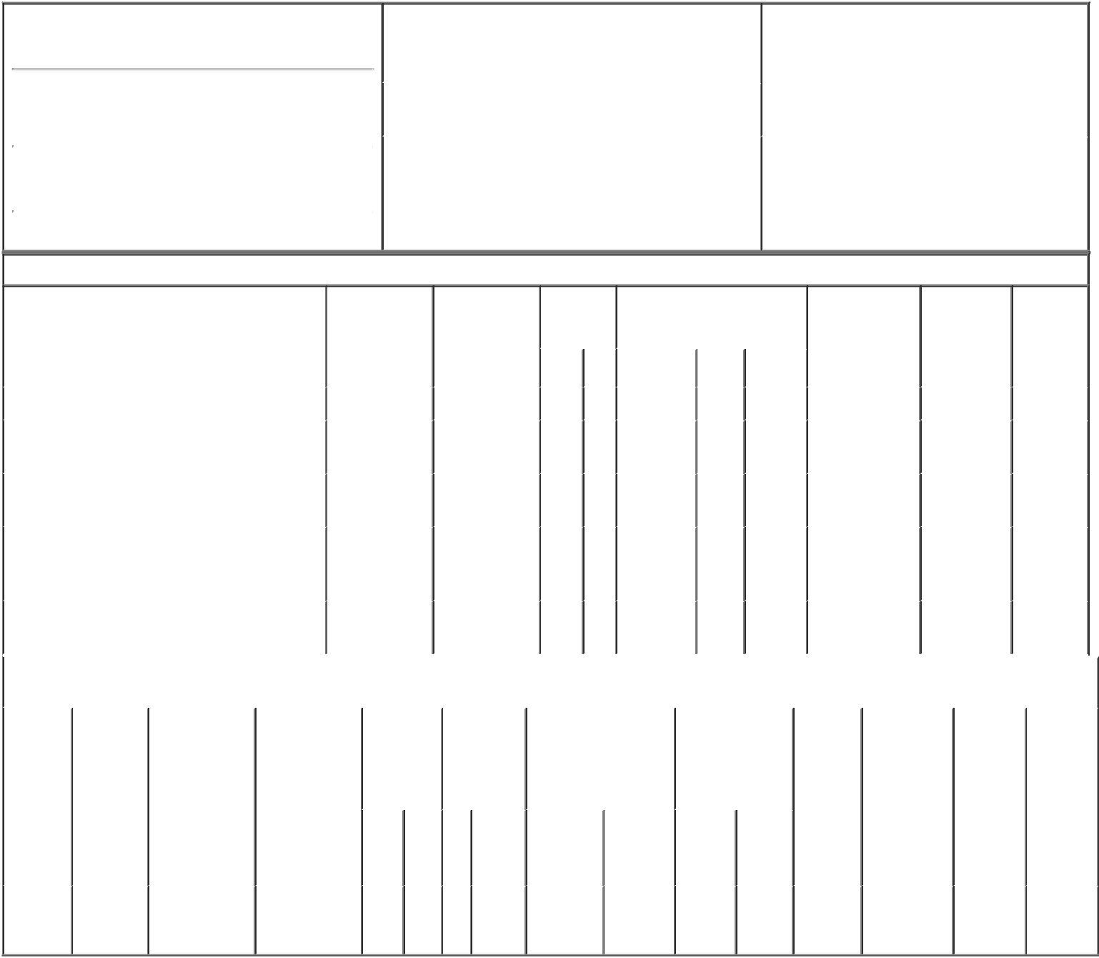

1. Name and Address of Reporting Person*
NIGON RICHARD

 | (Last) | (First) | (Middle)
 | 1331 TYLER STREET NE, SUITE 200
(Street)
 | MINNEAPOLIS MN |  | 55413
 | (City) | (State) | (Zip)

2. |  | Issuer Name and Ticker or Trading Symbol |  | 5. | Relationship of Reporting Person(s) to Issuer
 | TACTILE SYSTEMS TECHNOLOGY INC |  |  | (Check all applicable)
 | [ TCMD ] |  |  |  | X | Director | 10% Owner
 |  |  |  |  |  | Officer (give title | Other (specify
3. |  | Date of Earliest Transaction (Month/Day/Year) |  |  |  | below) | below)
12/13/2016
4. |  | If Amendment, Date of Original Filed (Month/Day/Year) |  | 6. | Individual or Joint/Group Filing (Check Applicable
Line)
X Form filed by One Reporting Person

Form filed by More than One Reporting
Person

Table I - Non-Derivative Securities Acquired, Disposed of, or Beneficially Owned

 | 1. Title of Security (Instr. 3) |  |  | 2. Transaction |  | 2A. Deemed | 3. |  | 4. Securities Acquired (A) or |  |  |  |  | 5. Amount of |  | 6. Ownership |  | 7. Nature of
 |  |  |  | Date |  | Execution Date, |  | Transaction Disposed Of (D) (Instr. 3, 4 and |  |  |  |  |  | Securities |  | Form: Direct |  | Indirect
 |  |  |  | (Month/Day/Year) |  | if any |  | Code (Instr. | 5) |  |  |  |  | Beneficially |  | (D) or Indirect |  | Beneficial
 |  |  |  |  |  | (Month/Day/Year) 8) |  |  |  |  |  |  |  | Owned Following |  | (I) (Instr. 4) |  | Ownership
 |  |  |  |  |  |  |  |  |  |  |  |  |  | Reported |  |  |  | (Instr. 4)
 |  |  |  |  |  |  |  | Code V | Amount | (A) or | Price |  |  | Transaction(s)
 |  |  |  |  |  |  |  |  |  | (D) |  |  |  | (Instr. 3 and 4)
 | Common Stock |  |  | 12/13/2016 |  |  |  | M | 6,103 | A | $0.68 |  | 14,755 |  |  |  | D
 | Common Stock |  |  |  |  |  |  |  |  |  |  |  | 5,175 |  |  |  | I | By
 |  |  |  |  |  |  |  |  |  |  |  |  |  |  |  |  |  | IRA⁽¹⁾
 | Common Stock |  |  |  |  |  |  |  |  |  |  |  | 14,471 |  |  |  | I | By SEP
 |  |  |  |  |  |  |  |  |  |  |  |  |  |  |  |  |  | IRA⁽²⁾
 |  |  |  |  |  |  |  |  |  |  |  |  |  |  |  |  |  | By
 | Common Stock |  |  |  |  |  |  |  |  |  |  |  | 9,000 |  |  |  | I | Rollover
 |  |  |  |  |  |  |  |  |  |  |  |  |  |  |  |  |  | IRA⁽³⁾
 | Common Stock |  |  |  |  |  |  |  |  |  |  |  | 66,470 |  |  |  | I | By
 |  |  |  |  |  |  |  |  |  |  |  |  |  |  |  |  |  | Trust⁽⁴⁾
 |  |  |  | Table II - Derivative Securities Acquired, Disposed of, or Beneficially Owned
 |  |  |  | (e.g., puts, calls, warrants, options, convertible securities)
 | 1. Title of | 2. | 3. Transaction | 3A. Deemed | 4. | 5. Number of | 6. Date Exercisable and |  |  | 7. Title and |  |  | 8. Price of |  | 9. Number of |  | 10. | 11. Nature
 | Derivative | Conversion | Date | Execution Date, | Transaction | Derivative | Expiration Date |  |  | Amount of |  |  | Derivative |  | derivative |  | Ownership of Indirect
 | Security | or Exercise | (Month/Day/Year) | if any | Code (Instr. | Securities | (Month/Day/Year) |  |  | Securities |  |  | Security |  | Securities |  | Form: | Beneficial
 | (Instr. 3) | Price of |  | (Month/Day/Year) | 8) | Acquired (A) |  |  |  | Underlying |  |  | (Instr. 5) |  | Beneficially |  | Direct (D) | Ownership
 |  | Derivative |  |  |  | or Disposed |  |  |  | Derivative Security |  |  |  |  | Owned |  | or Indirect | (Instr. 4)
 |  | Security |  |  |  | of (D) (Instr. |  |  |  | (Instr. 3 and 4) |  |  |  |  | Following |  | (I) (Instr. 4)
 |  |  |  |  |  | 3, 4 and 5) |  |  |  |  |  |  |  |  | Reported
 |  |  |  |  |  |  |  |  |  |  |  |  |  |  | Transaction(s)
 |  |  |  |  |  |  |  |  |  |  | Amount |  |  |  | (Instr. 4)
 |  |  |  |  |  |  |  |  |  |  | or
 |  |  |  |  |  |  |  |  |  |  | Number
 |  |  |  |  |  |  | Date |  | Expiration |  | of
 |  |  |  |  | Code V | (A) (D) | Exercisable |  | Date | Title | Shares
 | Stock
 | Option | $0.68 | 12/13/2016 |  | M | 6,103⁽⁵⁾ | (6) |  | 12/04/2022 | Common | 6,103 |  | $0 |  | 0 |  | D
 | (right to |  |  |  |  |  |  |  |  | Stock
buy)

Explanation of Responses:

1. Represents securities held by Stifel Nicolaus Custodian FBO Richard J. Nigon IRA Acct.

2. Represents securities held by Stifel Nicolaus Custodian FBO Richard J. Nigon SEP IRA Acct.

3. Represents securities held by Stifel Nicolaus Custodian for Richard Nigon / Rollover IRA.

4. Represents securities held by Richard Nigon, Trustee of the Mary Nigon Revocable Trust under Agreement dated August 19, 2015.

5. The reporting person's Form 3 filed on July 27, 2016 inadvertently understated the reporting person's stock option by 2 shares.

6. Fully vested.

 | /s/ Jonathan R. Zimmerman, |  |  | 12/15/2016
 | Attorney-in-Fact
 | ** Signature of Reporting Person |  |  | Date
Reminder: Report on a separate line for each class of securities beneficially owned directly or indirectly.
* If the form is filed by more than one reporting person, see Instruction 4 (b)(v).

- Intentional misstatements or omissions of facts constitute Federal Criminal Violations See 18 U.S.C. 1001 and 15 U.S.C. 78ff(a). Note: File three copies of this Form, one of which must be manually signed. If space is insufficient, see Instruction 6 for procedure.

Persons who respond to the collection of information contained in this form are not required to respond unless the form displays a currently valid OMB Number.

