SEC Form 4

FORM 4

Check this box if no longer subject to Section 16. Form 4 or Form 5 obligations may continue. See Instruction 1(b).

UNITED STATES SECURITIES AND EXCHANGE COMMISSION
Washington, D.C. 20549
 |  | OMB APPROVAL
STATEMENT OF CHANGES IN BENEFICIAL OWNERSHIP
 |  | OMB Number: | 3235-0287
 |  | Estimated average burden
Filed pursuant to Section 16(a) of the Securities Exchange Act of 1934 |  | hours per response: | 0.5
or Section 30(h) of the Investment Company Act of 1940
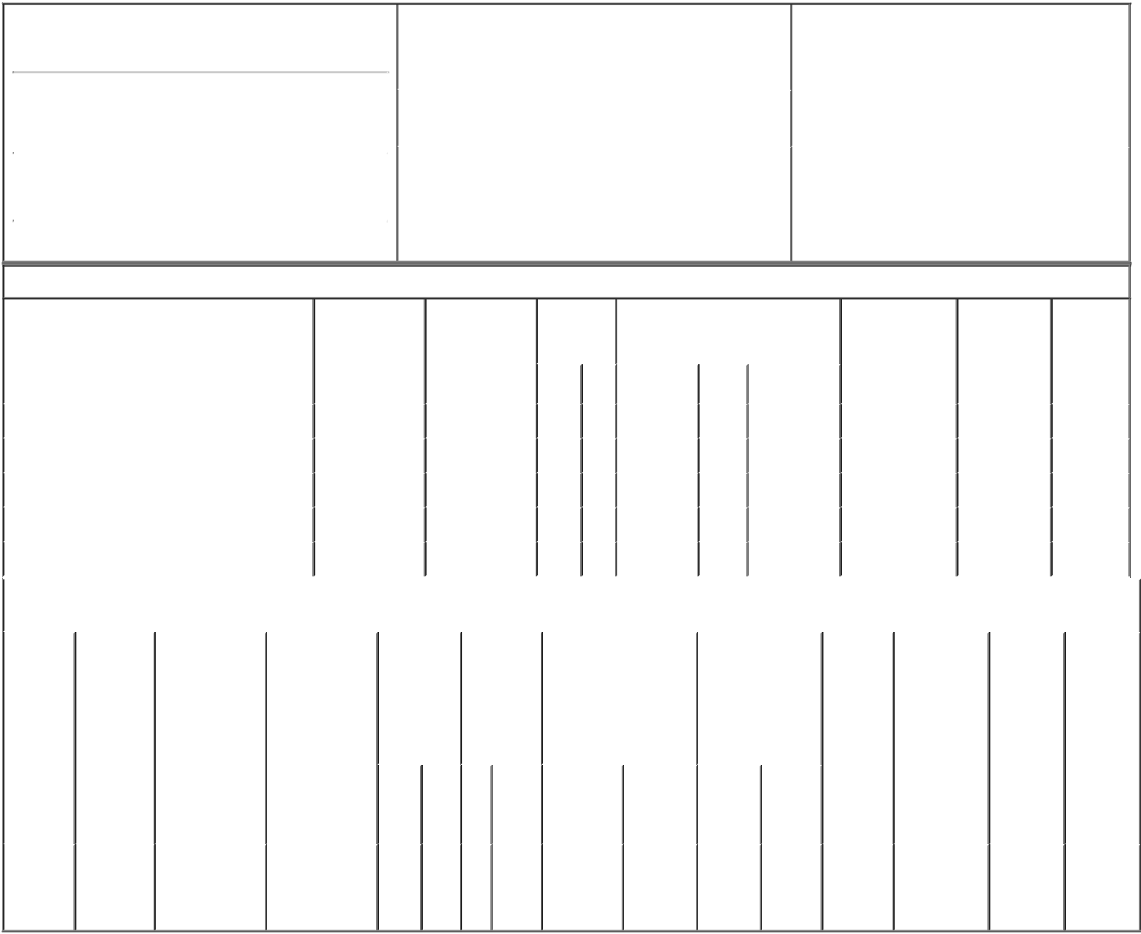

1. Name and Address of Reporting Person*
Mattys Gerald R.

 | (Last) | (First) | (Middle)
 | 1331 TYLER STREET NE, SUITE 200
(Street)
 | MINNEAPOLIS MN |  | 55413
 | (City) | (State) | (Zip)

 | 2. Issuer Name and Ticker or Trading Symbol |  | 5. Relationship of Reporting Person(s) to Issuer
 | TACTILE SYSTEMS TECHNOLOGY INC ^{(Check} ^{all applicable)}
 | [ TCMD ] |  | X | Director | 10% Owner
 |  |  | X | Officer (give title | Other (specify
 |  |  |  | below) | below)
 | 3. Date of Earliest Transaction (Month/Day/Year)
 |  |  |  | Chief Executive Officer
09/17/2018
 | 4. If Amendment, Date of Original Filed (Month/Day/Year) |  | 6. Individual or Joint/Group Filing (Check Applicable
Line)
X Form filed by One Reporting Person

Form filed by More than One Reporting
Person

Table I - Non-Derivative Securities Acquired, Disposed of, or Beneficially Owned

 | 1. Title of Security (Instr. 3) |  |  | 2. Transaction |  | 2A. Deemed |  | 3. | 4. Securities Acquired (A) or |  |  |  | 5. Amount of |  | 6. Ownership |  | 7. Nature
 |  |  |  | Date |  | Execution Date, |  | Transaction | Disposed Of (D) (Instr. 3, 4 and 5) |  |  |  | Securities |  | Form: Direct |  | of Indirect
 |  |  |  | (Month/Day/Year) |  | if any |  | Code (Instr. |  |  |  |  | Beneficially |  | (D) or Indirect |  | Beneficial
 |  |  |  |  |  | (Month/Day/Year) |  | 8) |  |  |  |  | Owned Following |  | (I) (Instr. 4) |  | Ownership
 |  |  |  |  |  |  |  |  |  |  |  |  | Reported |  |  |  | (Instr. 4)
 |  |  |  |  |  |  |  | Code V | Amount | (A) or | Price |  | Transaction(s)
 |  |  |  |  |  |  |  |  |  | (D) |  |  | (Instr. 3 and 4)
 | Common Stock |  |  | 09/17/2018 |  |  |  | _{M}(1) | 21,098 | A | $1.55 |  | 315,227 |  |  | D
 | Common Stock |  |  | 09/17/2018 |  |  |  | _{S}(2) | 11,118 | D | $65.3364⁽³⁾ |  | 304,109 |  |  | D
 | Common Stock |  |  | 09/17/2018 |  |  |  | _{S}(2) | 5,450 | D | $66.5154⁽⁴⁾ |  | 298,659 |  |  | D
 | Common Stock |  |  | 09/17/2018 |  |  |  | _{S}(2) | 1,530 | D | $67.1263⁽⁵⁾ |  | 297,129 |  |  | D
 | Common Stock |  |  | 09/17/2018 |  |  |  | _{S}(2) | 3,000 | D | $68.455⁽⁶⁾ |  | 294,129 |  |  | D
 |  |  |  | Table II - Derivative Securities Acquired, Disposed of, or Beneficially Owned
 |  |  |  | (e.g., puts, calls, warrants, options, convertible securities)
 | 1. Title of | 2. | 3. Transaction | 3A. Deemed | 4. |  | 5. Number | 6. Date Exercisable and |  | 7. Title and Amount |  | 8. Price of |  | 9. Number of |  | 10. | 11. Nature
 | Derivative | Conversion | Date | Execution Date, | Transaction |  | of | Expiration Date |  | of Securities |  | Derivative |  | derivative |  | Ownership | of Indirect
 | Security | or Exercise | (Month/Day/Year) | if any | Code (Instr. |  | Derivative | (Month/Day/Year) |  | Underlying |  | Security |  | Securities |  | Form: | Beneficial
 | (Instr. 3) | Price of |  | (Month/Day/Year) | 8) |  | Securities |  |  | Derivative Security |  | (Instr. 5) |  | Beneficially |  | Direct (D) | Ownership
 |  | Derivative |  |  |  |  | Acquired |  |  | (Instr. 3 and 4) |  |  |  | Owned |  | or Indirect | (Instr. 4)
 |  | Security |  |  |  |  | (A) or |  |  |  |  |  |  | Following |  | (I) (Instr. 4)
 |  |  |  |  |  |  | Disposed |  |  |  |  |  |  | Reported
 |  |  |  |  |  |  | of (D) (Instr. |  |  |  |  |  |  | Transaction(s)
 |  |  |  |  |  |  | 3, 4 and 5) |  |  |  |  |  |  | (Instr. 4)
 |  |  |  |  |  |  |  |  |  |  | Amount
 |  |  |  |  |  |  |  |  |  |  | or
 |  |  |  |  |  |  |  |  |  |  | Number
 |  |  |  |  |  |  |  | Date | Expiration |  | of
 |  |  |  |  | Code | V | (A) (D) | Exercisable | Date | Title | Shares
 | Employee
 | Stock |  |  |  | _{M}(1) |  |  | (7) |  | Common | 21,098
 | Option | $1.55 | 09/17/2018 |  |  |  | 21,098 |  | 04/20/2021 |  |  |  | $0 | 57,269 |  | D
 | (right to |  |  |  |  |  |  |  |  | Stock
buy)

Explanation of Responses:

- Stock option exercise effected pursuant to a Rule 10b5-1 trading plan adopted by the reporting person on August 21, 2018.

- Sales effected pursuant to a Rule 10b5-1 trading plan adopted by the reporting person on August 21, 2018.

- Reflects the weighted average price of 11,118 shares of common stock of Tactile Systems Technology, Inc. sold by the reporting person in multiple transactions on September 17, 2018 with sale prices ranging from $64.98 to $65.96 per share. The reporting person undertakes to provide upon request by the U.S. Securities and Exchange Commission staff, the issuer, or a security holder of the issuer, full information regarding the number of shares sold at each separate price.

- Reflects the weighted average price of 5,450 shares of common stock of Tactile Systems Technology, Inc. sold by the reporting person in multiple transactions on September 17, 2018 with sale prices ranging from $65.98 to $66.97 per share. The reporting person undertakes to provide upon request by the U.S. Securities and Exchange Commission staff, the issuer, or a security holder of the issuer, full information regarding the number of shares sold at each separate price.

- Reflects the weighted average price of 1,530 shares of common stock of Tactile Systems Technology, Inc. sold by the reporting person in multiple transactions on September 17, 2018 with sale prices ranging from $66.99 to $67.92 per share. The reporting person undertakes to provide upon request by the U.S. Securities and Exchange Commission staff, the issuer, or a security holder of the issuer, full information regarding the number of shares sold at each separate price.

- Reflects the weighted average price of 3,000 shares of common stock of Tactile Systems Technology, Inc. sold by the reporting person in multiple transactions on September 17, 2018 with sale prices ranging from $68.20 to $68.60 per share. The reporting person undertakes to provide upon request by the U.S. Securities and Exchange Commission staff, the issuer, or a security holder of the issuer, full information regarding the number of shares sold at each separate price.

- Fully vested.

/s/ Jonathan R. Zimmerman, |  |  | 09/19/2018
Attorney-in-Fact
** Signature of Reporting Person |  |  | Date

Reminder: Report on a separate line for each class of securities beneficially owned directly or indirectly.

* If the form is filed by more than one reporting person, see Instruction 4 (b)(v).

- Intentional misstatements or omissions of facts constitute Federal Criminal Violations See 18 U.S.C. 1001 and 15 U.S.C. 78ff(a). Note: File three copies of this Form, one of which must be manually signed. If space is insufficient, see Instruction 6 for procedure.
Persons who respond to the collection of information contained in this form are not required to respond unless the form displays a currently valid OMB Number.

